link_MercadoLibre

*Version 22.2.0*



Table of Contents

**Summary** **3**

**Component Overview** **4**

*Functional Overview* *4*

*Use Cases* *4*

*Limitations, Constraints* *4*

*Compatibility* *4*

*Privacy, Payment* *4*

**Implementation Guide** **5**

*Setup of Business Manager* *5*

*Configuration* *5*

*Custom Code* *5*

*External Interfaces* *5*

*Firewall Requirements* *5*

**Testing** **6**

**Operations, Maintenance** **7**

*Data Storage* *7*

*Availability* *7*

*Failover/Recovery Process* *7*

*Support* *7*

**User Guide** **8**

*Roles, Responsibilities* *8*

*Business Manager* *8*

*Storefront Functionality* *8*

**Known Issues** **8**

**Release History** **8**

# Summary

int_mercadopago is a payment processor maintained by Mercado Pago (Company of Mercado Libre group). It integrates Salesforce Cloud Commerce with Mercado Pago's payment API. It provides two payment methods: PIX (a Brazilian payment method) and Credit Card.

To use this cartridge you need to have an account at Mercado Pago ([https://www.mercadopago.com](https://mercadopago.com)).

# Component Overview

## Functional Overview

int_mercadopago plugin integrates the Salesforce Commerce Cloud platform, through SFRA Architecture, with Mercado Pago payment API. It offers components that process, validates, authorizes and notifies payments. The current version of this plugin offers two payment methods, that are:

* PIX
* Credit card
* Checkout Pro

PIX is a payment method accepted only in Brazil. It is an instant funds transfer between banking accounts. This payment method is maintained by Brazil's Central Bank.

Checkout Pro is a payment method that allows customers to make purchases through the Mercado Pago web form. When paying with Checkout Pro, the buyer is directed to a Mercado Pago page where they will complete the transaction safely and quickly and can pay with the main payment methods currently available.

This version offers integration for Brazil (pt_BR), Argentina (es_AR), Colombia (es_CO), Chile (es_CL), Mexico (es_MX), Peru (es_PE) and Uruguay (es_UY) localized e-commerce.

## Use Cases

During checkout it is provided three payment methods: Credit card, PIX and Checkout Pro.

**Credit card payment**

On credit card payment, after filling out the payment data form, still in the frontend, the SDK (officially maintained by Mercado Pago) is used to create the card token, tokenizing the payment operation sent to the API. As soon as the payment is received in the backend, the components provided by the plugin will process the payment and validate the data sent through the payment form. If there is no inconsistency in validation, the payment is created at Mercado Pago using the SDK provided by this component.

**PIX payment**

On PIX payment, after filling out the payment data form, the SDK (officially maintained by Mercado Pago) is used to create the payment QRCode, which is presented to the buyer to finish the checkout. As soon as the payment is received in the backend, the components provided by the plugin will process the payment and validate the data sent through the payment form. If there is no inconsistency in validation, the payment is created at Mercado Pago using the SDK provided by this component.

**Checkout Pro**

On Checkout Pro, when placing the order, the buyer is redirected to Mercado Pago page to complete the transaction. All payment validations are made on this page and, when completed, the buyer is redirected again to the store completed page. Payment confirmation is received on the store by notification.

## Limitations, Constraints

Mercado Pago provides a set of services that is not provided by this cartridge, including refund, favorite card selection, among others. These and other functionalities will be added in future versions of this plugin.

For more information about Mercado Pago and its services, access <https://www.mercadopago.com.br>

## Compatibility

Available since Commerce Cloud 22.8, compatible with SFRA version 6.1.0

## Privacy, Payment

No unmasked card data is persisted in Commerce Cloud. The cartridge tokenized card data using Mercado Pago SDK still at client-side. This way, the unmasked credit card number (PAN) is never sent to the Commerce Cloud server-side. The payments are created using data coming from the tokenization process previously mentioned.

Once the payment notifications are received by the cartridge via Web Hooks at Commerce Cloud, their existence and update are checked at Mercado Pago by the payment ID.

# Implementation Guide

## Setup of Business Manager

**Prerequisites**

You need to follow 4 main steps to install this cartridge into your site: integrate the cartridge's code into your site's code, build, upload and configuration. These steps are detailed below.

But before you start integrating int_mercadopago, you must have installed and configured:

* nodejs 14.20.00

**Instructions**

**Important:** create a sandbox store first to test the cartridge functionality and behaviors and then replicate all configurations into your production environment.

1. Plugin integration with store site:

First, download the current state of your store site. Go to Administration > Site Development > Code Deployment. Enter the active version and download it. Uncompress the downloaded .zip file.

Now download the latest version of int_mercadopago from the Salesforce Marketplace and uncompress it. Copy the contents of this .zip file into the same folder of the store site. This way, the folder int_mercadopago must be at the same level of the app_storefront_base folder

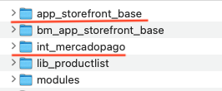.

2. Build

To get the cartridge working with your site, you need to integrate it to the store in a way that keeps its functionality along with other cartridges you may have installed. To accomplish this, you need to build the store.

Open a Command Prompt terminal and go to the int_mercadopago folder. Run the following commands:

npm install

npm run build

Now you have the cartridge code integrated into the store site.

3. Upload

You may use a WebDAV compatible tool to upload and deploy the site. Follow Salesforce documentation.

## Configuration

To activate int_mercadopago you need to configure it to be used as a payment processor.

1. Go to the Salesforce configuration panel, at Administration > Sites > Manage Sites > <your site> > Settings. Add int_mercadopago to the list of cartridges as the first item (or, at least, before the app_storefront_base).
2. Compress the int_mercadopago/metadata folder to a zip file.
3. In Administration -> Site Development -> Site Import & Export, upload this zip file using the Upload option
4. Select the uploaded zip and import it using the Import option.
5. Scroll to the end of this page and check the results at the Status section.

Configuring Mercado Pago credentials

To use Mercado Pago with Cloud Commerce, you must have a Mercado Pago account. Follow Mercado Pago's documentation to generate your credentials. After that, go to Merchant Tools > Custom Preferences > MercadopagoCredentials and fill the Public Key and Access Token fields.

Now you are ready to use int_mercadopago in your store site.

Optional configuration.

For payments with PIX, you can configure the payment expiration date, go to the menu Merchant Tools > Custom Preferences > Mercado Pago Payments Preferences and select the value in an interval of 15 minutes to 7 days.

IntegratorId with this number, we are able to identify all your transactions and know how many sales were processed using your account. Become a certified Mercado Pago partner and request your integrator_id [here](https://www.mercadopago.com.br/developers/en/developer-program).

## External Interfaces

This plugin functionality relies on external calls to the Mercado Pago API. No other external interface is used.

The Mercado Pago API endpoints are configured on the Meta Data upload step mentioned in the previous topic.

## Firewall Requirements

No requirements

# Testing

This cartridge has a set of unit tests to assure code functionality.

Once the cartridge is installed and integrated based into your store site, please try to place an order on your sandbox environment to test the storefront functionality:

**Important!** Place all test orders using an email ended with @testuser.com. This will make possible test transactions with test credit cards and other payment methods.

**Checkout with credit card:**

Step 1: Add Product into cart.

Step 2: Click on "Checkout" button.

Step 3: Checkout as a guest user.

Step 4: Fill shipping data.

Step 5: Click on "Next: Payment" button.

Step 6: Fill billing the form with any valid data.

Step 7: Select payment method as "Credit card" and a test credit card data from <https://www.mercadopago.com.br/developers/en/docs/checkout-api/integration-test/test-cards>

Step 8: Finish payment

**Checkout with PIX:**

Step 1: Add Product into cart.

Step 2: Click on "Checkout" button.

Step 3: Checkout as a guest user.

Step 4: Fill shipping data.

Step 5: Click on "Next: Payment" button.

Step 6: Fill billing the form with any valid data.

Step 7: Select payment method as "PIX". It will generate a QRCode. If its payment is not completed after 24 hours, Mercado Pago will send a notification and the order is canceled.

There is no way to make a test payment with PIX. You may place a 0.01 BRL order and make an actual payment. Once the payment is confirmed, Mercado Pago will send a confirmation notification.

**Checkout Pro:**

Step 1: Add Product into cart.

Step 2: Click on "Checkout" button.

Step 3: Checkout as a guest user.

Step 4: Fill shipping data.

Step 5: Click on "Next: Payment" button.

Step 6: Select payment method as "Mercado Pago"

Step 7: Complete the transaction on Mecado Pago page using one of the available payment methods following the instructions on the screen

# Operations, Maintenance

## Data Storage

Order Custom attributes:

* paymentReport (string): last reported payment status by Mercado Pago
* paymentStatus (string): user friendly message for paymentReport

Order Payment Instrument custom attributes:

* payerEmail (string): email of the person who made the payment (not necessarily the customer)
* payerFirstName (string): first name of the person who made the payment
* payerLastName (string): last name of the person who made the payment
* payerDocType (string): document type of the person who made the payment
* payerDocNumber (string): document number of the person who made the payment
* payerQrCode (string): generated QRCode for PIX payment
* payerQrCodeBase64 (string): base64 encoded image of the generated QRCode for PIX payment

Site Preferences Custom attributes:

* MercadopagoCredentials
  + mercadopagoPublicKey (string): Mercado Pago public key credential
  + mercadopagoAccessToken (string): Mercado Pago access token credential
* MercadopagoPreferences
  + mercadopagoIntegratorId (string): ID that identifies a Mercado Pago Partner.
* MercadopagoPaymentsPreferences
  + mercadopagoPixExpirationTime (enum-of-string): PIX expiration time
    - 15 minutes
    - 30 minutes
    - 60 minutes
    - 24 hours
    - 2 days
    - 3 days
    - 4 days
    - 5 days
    - 6 days
    - 7 days

These data are kept during the period that Cloud Commerce keeps its order data.

## Availability

It's expected to have an availability of 99.94% of uptime. If you have any problem, contact the support team at <https://www.mercadopago.com.br/developers/pt/support>

In case the service fails, there is no fail-over to allow transactions to proceed. Users will instead be provided with friendly error messaging.

## Failover/Recovery Process

If the Mercado Pago service is unavailable the user will not be able to checkout. Users will instead be provided with friendly error messaging.

## Support

[For any support, please contact Mercado Pago Support](https://support.stripe.com/) at: <https://www.mercadopago.com.br/developers/pt/support>

# User Guide

## Roles, Responsibilities

There are no recurring tasks or jobs on this cartridge. Neither custom roles are required by it.

## Storefront Functionality

int_mercadopago adds three payment methods to the checkout form: credit card, PIX and Checkout Pro (Mercado Pago).

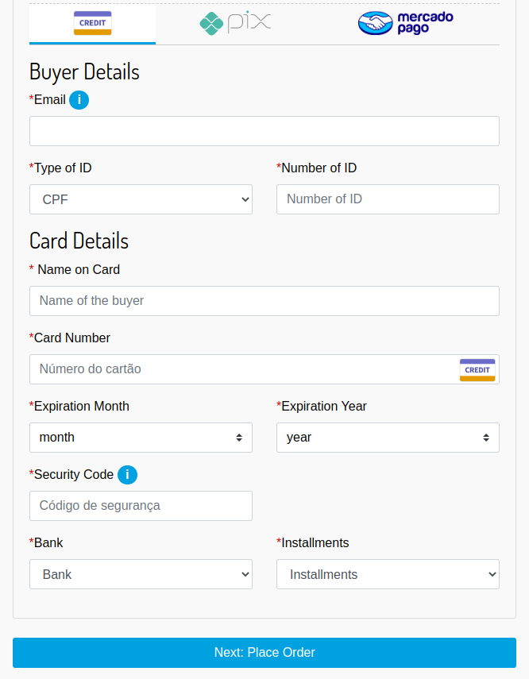

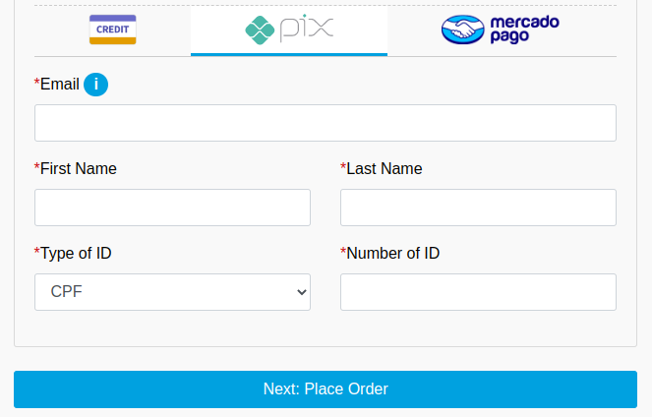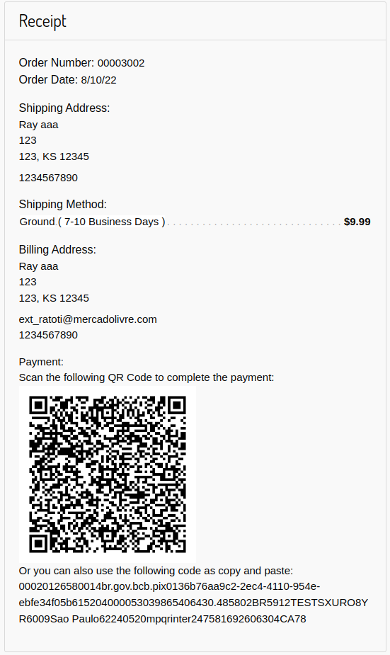

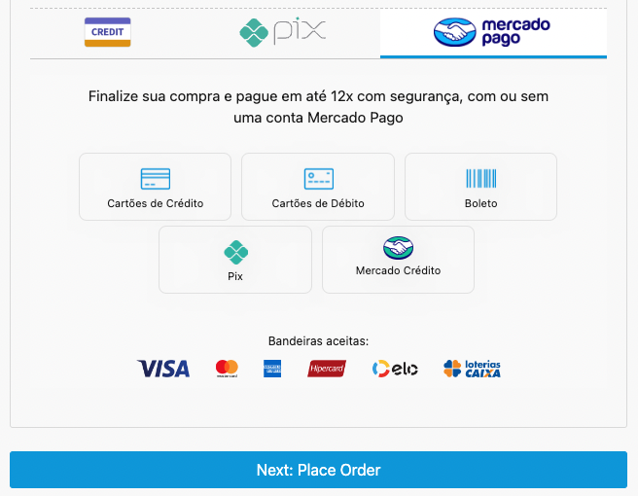

# Known Issues

There are no known issues in this version of the cartridge.

# Release History

| **Version** | **Date** | **Changes** |
| --- | --- | --- |
| 22.1.0 | 2022-08-10 | Initial release |
| 22.2.0 | 2022-11-17 | Add Checkout Pro payment method |
| 23.1.0 | 2023-01-4 | Improved texts and internationalization for US, PT and ES  Improvements in layouts  Centralization of plugin logs for int_mercadopago  Availability of configuration IntegratorId  Availability of configuration PIX Expiration  Submission Plugin Version  Sending the Issuer_ID in the CHO API |
| 23.2.0 | 2023-06-13 | Reduction of the scope of Transactions  Improved Log Management  Implementation JSON return in Notifications Retrieving cart value in submitShipping |